Electric Car Charger Robot Project Proposal

By Manqiu Yu, Xing Hao Li, Yixuan Xu

## 1. Introduction

This report will introduce the opportunity to design and construct an autonomous mechatronics system to plug in an electric car charger. Specifically, the system is designed to carry a 3D-printed dummy charger plug or an off-the-shelf J1772 charger plug into a 3D-printed SAEJ1772 Type 1 charging port.

This proposal will inform readers on requirements of the problem, alternative designs, testing processes, and details of the proposed design solution. In addition, specifics in project management within the design group will also be discussed.

## 2. Stakeholders and Requirements

Stakeholders

**Electric Car Owners**: *value reliability, ease of use, safety, and performance in real-world scenarios* [1]

**Praxis Student Design Team**: *values ease of construction and performance during a simulated test*

**The Environment**: *values reduced carbon footprint and promotes use of reusable products*

**Electric Car Manufacturers**: *value customer satisfaction and demand of products*

**Teaching Team**: *values feasibility in construction and performance of proposed design solution*

Requirements

The high-level objective of this opportunity is to **design an autonomous device that will accurately and reliably carry and transport a charger plug, locate a charging port, and insert the charger plug into the port** [2]**.** Specifically, the design team has chosen to attempt all additional tasks listed in the project outline [2], and focuses on designing for capability (in terms of accuracy and precision of controls and successfully performing the task), simplicity in operation, ease of assembly, feasibility in the scope of school course and in real world, and safety.

Detailed objectives, associated metrics, criteria for the overall mechatronics system are summarized in Appendix A. Specific metrics and test methods for individual subsystems and components are discussed in the “Converging Process” section and listed in Appendix A.

## 3. Alternative Designs and Choice of Components

For all three designs, the sensing and locating sub-system works the same. During operation, a camera positioned under the charging plug mount detects the angle and position of the charging port, while ultrasonic sensors and gyroscopes are used alongside to confirm the position of the charging plug. The differences among the three designs lie in the method of movement.

**Design 1: Cartesian robot with linear motion tracks and servo-powered rotating gripper**

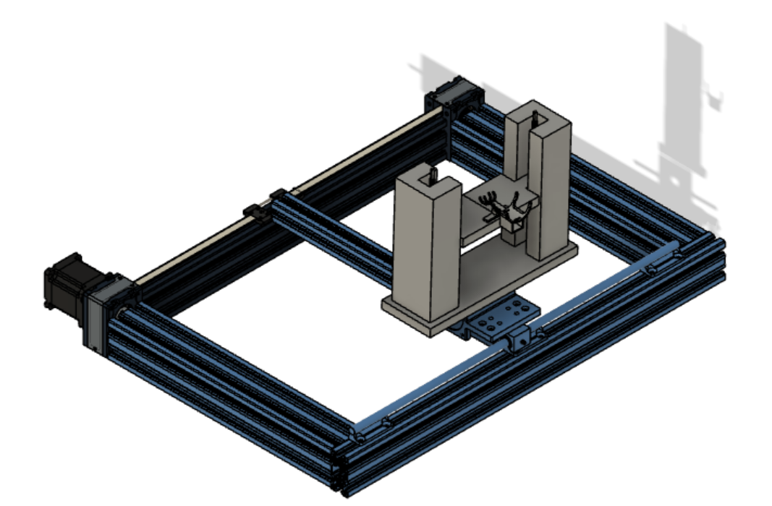

*Figure 1: CAD design of design 1*

This design uses a fixed base that has a base area of 1 m by 0.5 m, with the longer side facing the vehicle. Movements in x-axis are achieved using a stepper-powered belt drive. Movement in y-axis is moved by rack and pinion. Movement in z-axis is achieved by two lead screws each powered by a stepper motor. The rotation, or yaw, of the charger plug is controlled by a servo-powered gripper that is connected to the nut on the lead screw. Movement in z-axis is done first, followed by a combined movement of x-axis, y-axis, and rotation of charger plug.

**Design 2: Fixed-base angular robot**

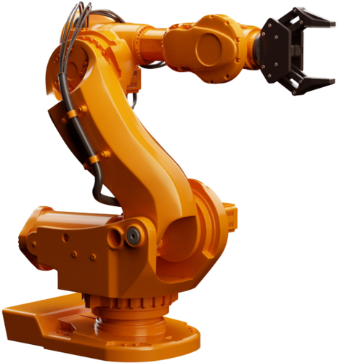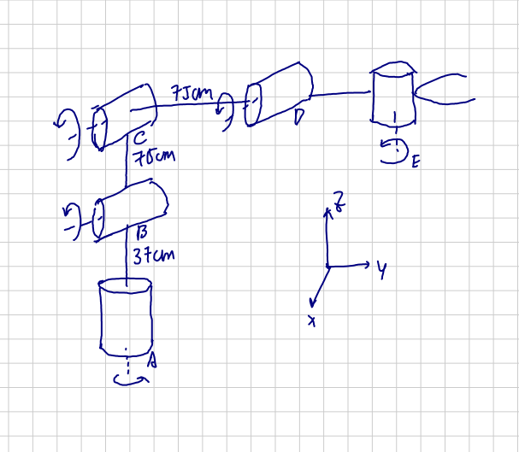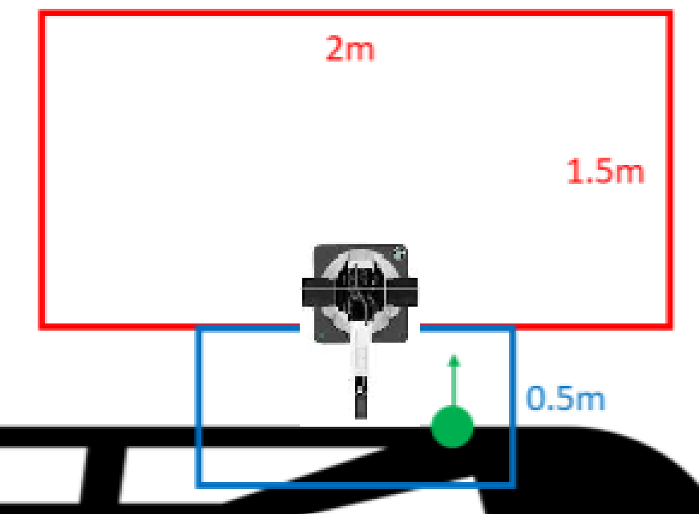

*Figure 2: Commercially Figure 3: Kinematics diagram Figure 4: Position of design 2 viewed*

*available robotic arm of design 2 from top*

This alternative is essentially an anthropomorphic robotic arm. It works in a similar fashion as shown in Figure 2, but with a less sophisticated mechanical design. As shown in Figure 3, it uses five serial joint linkages for moving the charger, and a gripper for holding the charger. All of which are powered by servo motors. Joint B is situated on a fixed height 37 cm from the base, at the centre-front of the setup area (shown in Figure 4). Joints B and C withdraw or extend the arm to up to 75 cm, and with the rotation by joint A, they enable the charger plug to reach anywhere inside the charging area. Joint D and E rotate the gripper to ensure that the charging plug is aligned with the port.

**Design 3: Wheeled Rover Base with Linear Motion Tracks**

The final design solution that we proceeded with is a combined system of a three-wheeled rover and two linear motion systems. The detailed description is elaborated in the subsequent section.

## 3. Proposed Design Solution

### 

*Figure 5: Overview of proposed design Figure 6: Detailed view of lead screw and gripper*

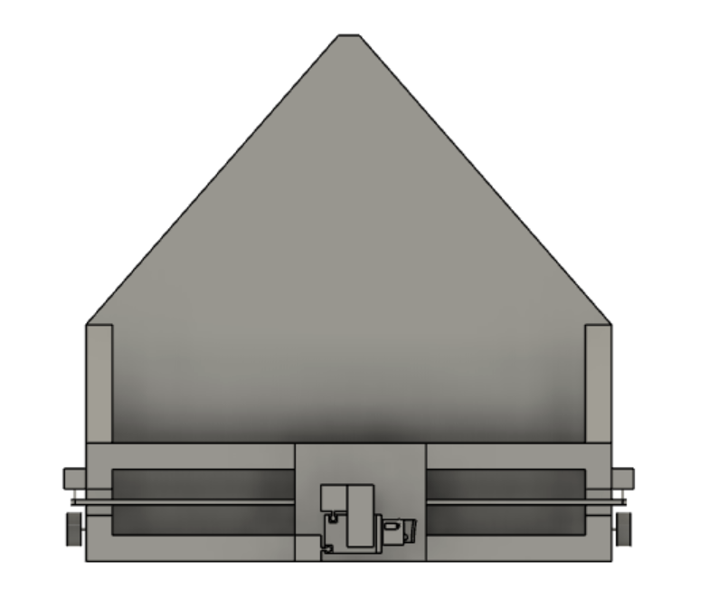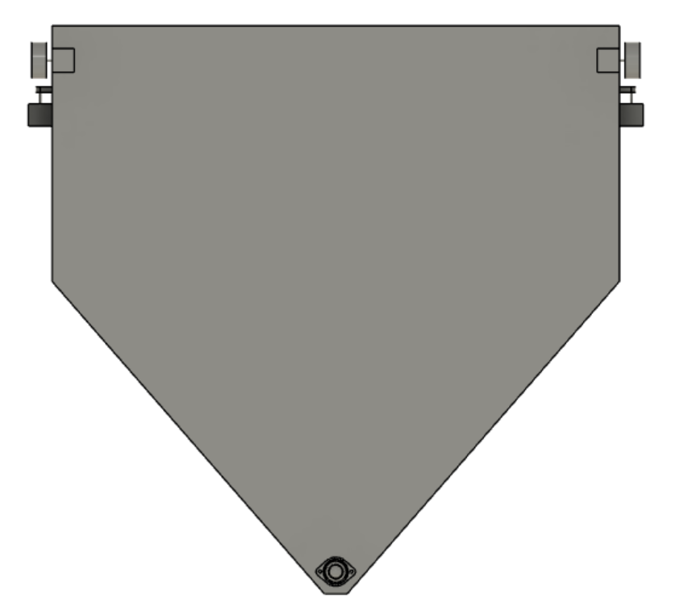

*Figure 7: Top view of proposed design Figure 8: Bottom view of proposed design*

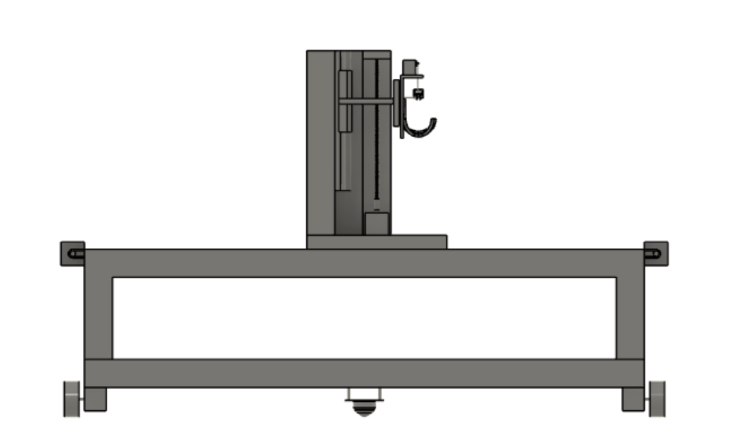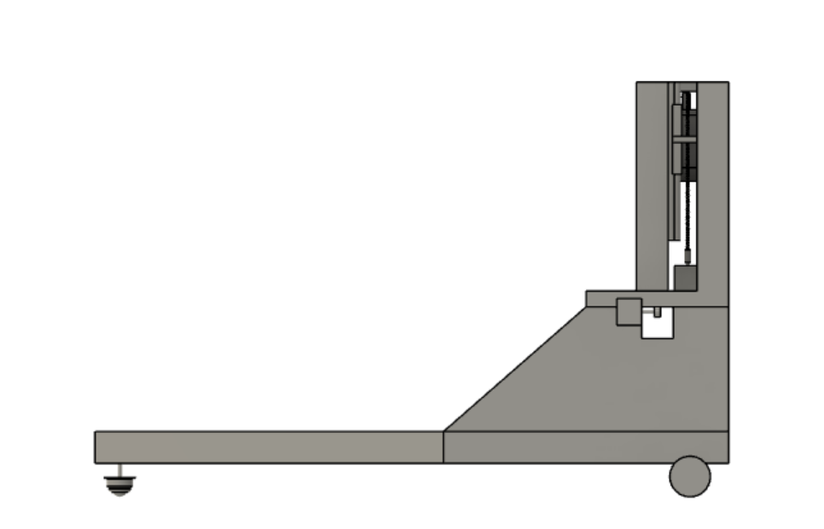

*Figure 9: Front view of proposed design* *Figure 10: Right-side view of proposed design*

### 3.1 Mobility Subsystem

The final design solution for mobility is a combined system of a three-wheeled rover and two linear motion systems. The important objectives that this design achieves are that only one degree of freedom is adjusted at a given time, and that the moment of inertia for the charging plug is minimized, thereby simplifying the operation and ensuring stability. The frame is built with 2’’x2’’ Balsa block, while the base and side plates are constructed using ¼’’ medium density fibreboard.

The pentagonal base consists of two stepper-powered 80x10mm wheels and a ball castor. This base will be responsible for both the y-axis (by powering two stepper motors) and yaw movement (by turning on only one stepper motor).

At 30 cm above the base, there is a rectangular platform that hosts the belt-drive linear motion system responsible for movement in x-axis. It aligns with the vehicle wall, and span for 1.2 m in length.

Sliding along the belt-drive linear motion system is a component responsible for z-axis movement and holding the charger. The linear motion is achieved by a 30 mm long 8mm lead screw supported by two 12mm linear slide rail tracks. To provide rigidity and minimize vibrations caused by rotation of the lead screw, each slide rail is placed perpendicular to each other.

The platform carried by the lead screw and guide rails is a 3D-printed charger gripper. It has a base that is casted by the STEP file of the charger plug, and so is designed to allow the plug to sit on perfectly. The gripper also has a servo motor with a linear motion linkage, which can be activated to press down on the button of the plug, to securely hold the charger and unlock the clipping of the plug at the same time. The camera, gyroscopes, and ultrasonic sensors are located on the front side of the charger gripper, beside where the charger plug sits.

### 3.2 Electrical Subsystem

The goal of the electrical subsystem is to integrate the software and mechanical parts of the design. The algorithm for detecting charging port location and angle relies on sensor data, such as camera images, ultrasonic sensor inputs, and accelerometer readings. This information is received and processed by the microcontroller, and the location and angle of the charging port is calculated. This calculation is then decoded into specific motor movements to deliver the charger to its correct position. The specific electrical components that perform the integration tasks are summarized in the table and circuit diagram below [3][4][5][6][7].

*Table 1: Summary of Electrical Components*

|  |  |
| --- | --- |
| Component | Functionality and Implementation |
| Raspberry Pi 4 | As a microcontroller, its main task is to integrate the sensor input and control motor movements. It will be connected to the 5 stepper motor drivers through its GPIO pins, and to the camera through USB3.0. |
| Stepper Motor 17HS19-2004S1 | This motor attaches to the lead screw, which is responsible for vertical movement of the charger. As the only motor working against both gravity and friction, it has a high torque rating with a holding torque of 59Ncm. It will be connected to and controlled by an A4988 motor driver, and driven directly by a power supply. |
| Stepper Motor 17HS15-1504S-X1 | Two of these motors drive the wheels that move the base, and another one facilitates the horizontal movement of the timing belt. These motors do not operate against gravity, therefore a more economic motor type is selected for these tasks. All three will be connected to and controlled by A4988 motor drivers, and powered by a power supply directly. |
| A4988 motor driver | There will be a total of four stepper motor drivers, all of which serve as an intermediate component between the microcontroller and stepper motors. In this way, the stepper motors are more accurately controlled and easier to work with. |
| Servo Motor MG996R | The purpose of the servo motor is to press down the spring clipping of the charger. It is directly connected to and controlled by the microcontroller through hardware PWM of GPIO pin 12. |
| Microsoft LifeCam HD-5000 | A web camera is used to deliver graphical input to the microcontroller. It will be connected to the microcontroller through a USB cable, and will be controlled by code programmed on the microcontroller. |
| MPU-9250 IMU | A common, cheap inertial measurement unit to keep track of the system’s position, and angle. It has the accelerometer, gyroscope, and the magnetometer combined in one unit. |
| HC-SR04 ultrasonic sensor | A simple ultrasonic sensor for detecting distance. |

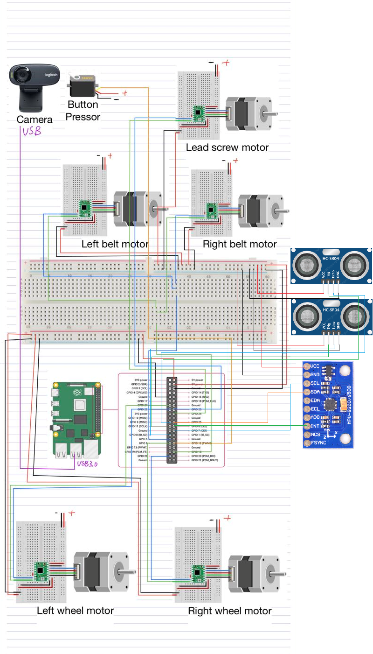

*Figure 11: Circuit design diagram*

### 3.3 System Strategy

The proposed design incorporates both the mechanical and the algorithmic perspectives. A high level flow chart is as follows:

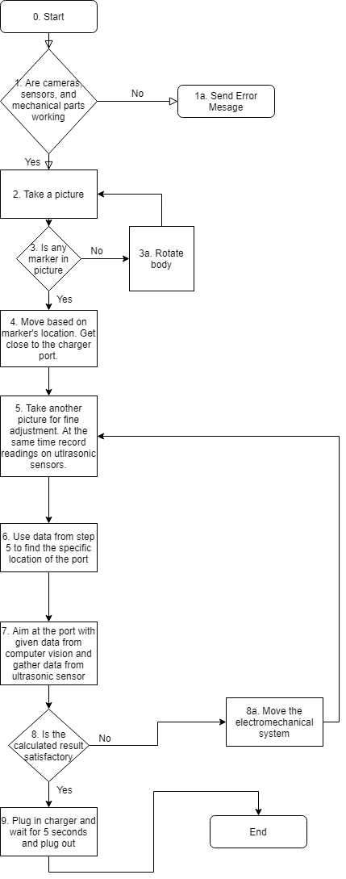

*Figure 12: Flowchart of sensing/locating algorithm*

0. Pre-setup would include putting multiple premade markers on the car, such that it is easily

detectable like a chessboard. After determining markers, the relative position between markers

and the charging port can be used for movement control. OpenCV has built-in functions for

finding chessboard corners, and it is easily detectable during our testing (see Appendix J). Having

many of these chessboard markers maximizes chances of detecting at least one of them at various

angles. If only one marker is detected, we could then know if the car is on the right or left. If

more than one markers are detected, then it gives a more complete picture of where the system is

located with respect to the car.

1. The first step is to check if the electromechanical system is ready, if any parts are disconnected or malfunctioning. We could stop and check right away by looking at error messages.
2. Initialize computer vision algorithm by first taking a picture. The camera is positioned on top of the robotics system to capture a good view of the front facing the charging port.
3. The picture should at least target one of the premade markers to generate useful data for further instructions, if not most of them. Otherwise the robot should rotate in attempts to find those markers and return to step 2. If none of the markers are detected, the robot should make random attempts in rotation to detect at least one marker, and therefore will tell us where the port is from their relative positions. However, this is not likely given that the camera’s field of view is quite wide. Using pose estimation techniques from OpenCV, the euler angles of axis rotation can be found, and therefore inform the mechanical parts about rotation. The pixel location of the marker in the picture also informs the translation movement.
4. Then the mechanical body can move based on information about the location of the charging port obtained in step 3. It will first translate towards that direction followed by a rotation to allow the camera at a perpendicular position to the charger’s orientation.
5. Since the previous step may be far away from the actual charging port, more adjustment is needed to align the charger with the port. To begin, take another picture. Some ultrasonic sensors are also employed at this point to detect distances between the mechanical parts and the charging port.
6. Check if any changes are needed according to calculations of data gathered from step 5.
7. Make any appropriate movement of the system according to results from step 6.
8. Plug in the charger by advancing the robotic arm forward.
9. Wait for 5 seconds and retract.

### 3.4 Risks and Challenges

Various risks and challenges are identified that may lead to failures during operation:

* The plywood beams received are not perfectly straight. When constructing, careful attention must be paid to ensure the frame is leveled and straightened, such as by using a spirit level, recutting the beam, or switching to other structural materials.
* The timing belt is stretched over a length of 1.2 m, which requires high tension between the stepper motor, pulley, and belt, and will be difficult to construct. A stretch-resistant timing belt should be selected.
* The platform held by the lead screw attaches the charger gripper on its side, which introduces rotational moment. Thus, the glide rails and lead screw must be able to hold the platform tightly to eliminate tilt and vibration.
* In terms of computer vision algorithm, markers may not have been recognized during the first step, and the system must take a random direction to rotate. Also, it may take too long before a marker is recognized.
* Another failure might be the inaccuracy with pose estimation. As noted in Appendix J, the camera is not totally accurate at angle measurement, and hence it might not give the right instructions. To mitigate this, we are also using ultrasonic sensors to compute distances.

### 3.5 Bill of Materials

*Table 2: Summary of purchased materials and costs*

|  |  |  |  |
| --- | --- | --- | --- |
| Item | Quantity | Unit Price | Total Cost |
| **Mechanical** |  |  |  |
| 2’’ x 2’’ Balsa block (<http://tiny.cc/lf3dkz>) | 18 ft | $3.50 | $63.00 |
| ¼’’ MDF board (<http://tiny.cc/lf3dkz>) | 9 sq ft | $0.64 | $5.76 |
| 80X10MM WHEEL - BLACK (<http://tiny.cc/lf3dkz>) | 2 | $2.29 | $4.58 |
| 5mm Aluminum Mounting Hub (<http://tiny.cc/6o3dkz>) | 2 | $2.65 | $5.30 |
| Ball castor (<http://tiny.cc/lf3dkz>) | 1 | $2.22 | $2.22 |
| Timing Belt Kit 6mm Width (<http://tiny.cc/xk3dkz>) | 1 | $1.45 | $1.45 |
| Spring-loaded ball castor for guide rails (<http://tiny.cc/lf3dkz>) | 4 | $1.75 | $7.00 |
| 30mm Lead Screw with Guide Rails (<http://tiny.cc/lf3dkz>) | 1 | $27.35 | $27.35 |
| **Electrical** |  |  |  |
| Raspberry Pi 4 1GB (<http://tiny.cc/em3dkz>) | 1 | $54.22 | $54.22 |
| Stepper Motor 17HS19-2004S1 (<http://tiny.cc/yi3dkz>) | 1 | $12.96 | $12.96 |
| Stepper Motor 17HS15-1504S-X1 (<http://tiny.cc/gj3dkz>**)** | 3 | $15.00 | $45.00 |
| A4988 motor driver (<http://tiny.cc/bh3dkz>) | 3 | $3.33 | $9.99 |
| Servo Motor MG996R (<http://tiny.cc/xq3dkz>) | 1 | $13.39 | $13.39 |
| Microsoft USB HD Webcam (<http://tiny.cc/mehekz>) | 1 | $17.99 | $17.99 |
| 20 mm Spst Round Rocker Switch (<http://tiny.cc/an4dkz>) | 1 | $1.00 | $1.00 |
| Ultrasonic sensors HCSR-04 (<http://tiny.cc/lf3dkz>) | 2 | $1.13 | $2.26 |
| IMU MPU-9250 (<http://tiny.cc/zb1ekz>) | 1 | $9.99 | $9.99 |
| **Total Cost** |  |  | **$283.46** |
| **Note:** Shipping is free as all materials are sourced from Amazon, LFF, and Creatron | | | |

## 4. Converging Process

### 4.1 Selecting the Overall Design

For the overall mobility system, we built low-fidelity prototypes to test according to protocols suggested by Carnegie Mellon University, and pugh chart to converge [8]. The specific test methods and verification data are available in Appendix C.

Design 1 fails due to its complexity in movement and concerns regarding its stability and repeatability. Because the rotation of the charger plug is achieved by the gripper, the plugging in of the charger requires simultaneous movement on x-axis, y-axis, and yaw, which was difficult to coordinate. Because the base is fixed, the charger plug gripper needs to be extended out of the initial setup area by as much as 50 cm to reach the charger port, which was proven difficult to maintain stability (see Appendix C).

For Design 2, similar issues occurred. Five degrees of freedom moving simultaneously was difficult to control. In addition, an extension of the robotics arm to as much as 75 cm caused instability for the gripper and bending of the structure.

Design 3 was chosen for its simplicity in movement and structural rigidity - only one degree of freedom is adjusted at a given time, and the movement of charger plug was proven to be stable.

### 4.2 Selecting the Structural Material

The selection of structural materials closely follows the method provided by Michael F. Ashby’s textbook on mechanical design, which includes translating design requirements, screening using constraints, ranking using objectives, and seeking documentation. These steps will be elaborated in Appendix D [7].

Given the required function and constraints, the relevant metrics are density, surface roughness, stiffness, and cost. Specifically, a lightweight and stiff material will reduce the requirements on motors, while enabling the system to attain a higher precision and repeatability in movement. A smooth surface allows the material to also be used as a guide rail for linear motion.

After eliminating materials that fail the constraints, the viable materials include spruce lumber, Balsa plywood, and aluminum extrusion. All materials achieve sufficient stiffness for the use case, as they do not exhibit visible deflection under a simulated stress test (see Appendix D). However, the Balsa plywood stands out as the most cost-effective choice. Spruce lumber is found to be difficult to machine through, as its moisture content caused bandsaw to wear out quickly. Its surface is also too rough to be used as a guide rail system for linear motion. Aluminium, on the other hand, is too costly and heavy, and its added strength is unnecessary for this application.

### 4.3 Selecting the Linear Motion System

Under the proposed design, the linear motion systems include a 120-cm long horizontal track, and a 23-cm vertical track. The possible choices that fit the cost constraint include lead screw, timing belt, and rack and pinion. Expensive options, such as ball screw or roller pinion systems, violate the cost constraint and thus were eliminated. The set of relevant requirements developed by Bosch Rexroth group are called “LOSTPED”, which stands for load, orientation, speed, travel length, precision (travel accuracy and final position), environment, and duty cycle [9][10].

After evaluating these requirements (see Appendix E), belt drive is chosen to drive the long horizontal track for its accuracy in long travel. Lead screw is chosen for the vertical track for its load-bearing ability [11]. Both linear motions are assisted by two guide guide rails on the sides of the linear motion actuator to reduce friction and vibration of motion.

### 4.4 Selecting the Stepper Motor, Servo Motor and Motor Driver

For our design, stepper motors are used to drive the wheeled base, the timing belt for movement in x-axis, and the lead screw for vertical leveling of the charger. Of the three tasks, leveling the charger requires the most torque as it is the only movement that works against both gravity and friction. We compared four different stepper motors (17HS15-1504S-X1, 17HS19-2004S1, 23HS22-3008D, 17HS4401S) and three servo motors (DS3218MG, SG90 9G, MG996R) (see Appendix F).

Motor calculations, which include number of pulses, step resolution, motor speed, and motor torque, are suggested by Automation Direct and are included in detail in Appendix F [12]. The requirements are then compared with the manufacturer specification sheets [13][14][15]. The maximum RPM required is calculated to be 491 RPM, well below the 1200 RPM capability of NEMA17 motor models [13]. The maximum required torque is 14.9Ncm, which is safely below the 50% threshold of 17HS19-2004S1 model operating at 491 RPM [15]. Because we acquired the 17HS19-2004S1 during Praxis workshops and the motor excels in the tasks required, it was conveniently chosen for the purpose of leveling the charger. For driving the base and the timing belt, less torque is required as the tasks do not require working against gravity. 17HS15-1504S-X1, which has less torque rating, but is lighter and cheaper, and provides sufficient torque, is selected to perform these tasks. MG996R is chosen as the servo motor for the clamping of charger gripper.

For motor drivers, we chose A4988 as it is tested to be capable of driving the chosen stepper motors, provides sufficient precision and ease of calibration, and is easily accessible from the LFF.

### 4.5 Selecting the Microcontroller

A microcontroller is responsible for integrating sensors, motors, and power supply, and then controlling the motors via motor drivers. Thus, to ensure the capability and feasibility of the system, the main metrics are compatibility with other electrical components, availability for purchase, and unit cost. As suggested by EE, key technical metrics are also considered, such as CPU clock speed, RAM, number of pins, and number of USB ports [16][17]. The via alternatives found include Raspberry Pi 4, Arduino Mega 2560 REV3, Arduino Uno, and Dragonboard 410 C.

After evaluating these requirements and scoring them on a pugh chart (see Appendix G), we chose Raspberry Pi to be our microcontroller for its best overall performance, compatibility with electrical components, connectivity options with Wifi and Bluetooth, and not-so-high price.

### 4.6 Selecting Distance Sensors and Camera

Selection of distance sensors is based on criteria derived from our objectives of target detection. Distance sensors are expected to output accurate distance readings, have a wide range for planes at different angles, and have an appropriate range for distance measurement for the set up. Two main types of sensors, ultrasonic and infrared red sensors, are commonly used. The main problem with the infrared red sensor was its dependence on the colour of surface, as noted in previous workshops. Thus, ultrasonic sensors are chosen as our distance sensor for its low cost and availability for purchase. There are many models of ultrasonic sensors such as the HC-SR04 and HY-SRF05, but from data sheets, the values are not too different [18]. As a result, we choose the most convenient sensor available to us, the HC-SR04 sensor. The sensor was then tested and verified (see Appendix H).

Camera requirements for computer vision are not different from requirements for any regular cameras. The camera is used for image capturing, and the image will be processed by the computer to extract key information from that image. Factors that are important are the compatibility with microcontroller, resolution, and effectiveness with computer vision libraries, namely OpenCV [19]. As a result of our testing, the Microsoft LifeCam is chosen. Detailed discussions, results, and pugh chart are listed in Appendix J.

### 4.7 Selecting the Inertial Measurement Unit

Both MPU-9250 and MPU-6050 are similar in price, very accessible through Amazon purchase, and has been recommended by the teaching team. One key information noted on their datasheets [20][21] is the lack of magnetometer on MPU-6050, while other parameters are identical such as mechanical frequencies, etc. An extra feature such as the magnetometer from the MPU-9250 is important in case of a back up plan.

### 4.8 Selecting the Power Supply

After selecting the microcontroller, the power supply is restricted to those that are compatible with Raspberry Pi. Possible options are using a micro USB supply, supplying power directly via its GPIO pins, or supplying power via the USB Ports [22]. The easiest and the safest option is to use the micro USB supply. See Appendix for further discussion.

## 5. Project Management

The project is mainly divided into two parts, mechanical mobility and charger detection. Tasks are divided among team members based on their strengths and interests. Yixuan and Xing Hao are mainly responsible for the mechanical design while Man Qiu works on charger detection with computer vision algorithms. Each member also does research on parts that are relevant to their own tasks.

Our team is using Trello to keep track of all the tasks that need to be completed. We have divided each task into different categories depending on its priority. Tasks in the Priority columns are more detailed and also means that they are closely related to the upcoming evaluations. Deadlines are also included on Trello to remind everyone of upcoming evaluations. Deadlines are also set for detailed tasks that come before milestones such as assembly and calibration. Once a task has been completed or a deadline has passed, we would put these items in the “Done” category. They will not be deleted and will be available for viewing as a reference. Members can login and comment on each item. Task assignment can be seen from their initials near the bottom of each task.

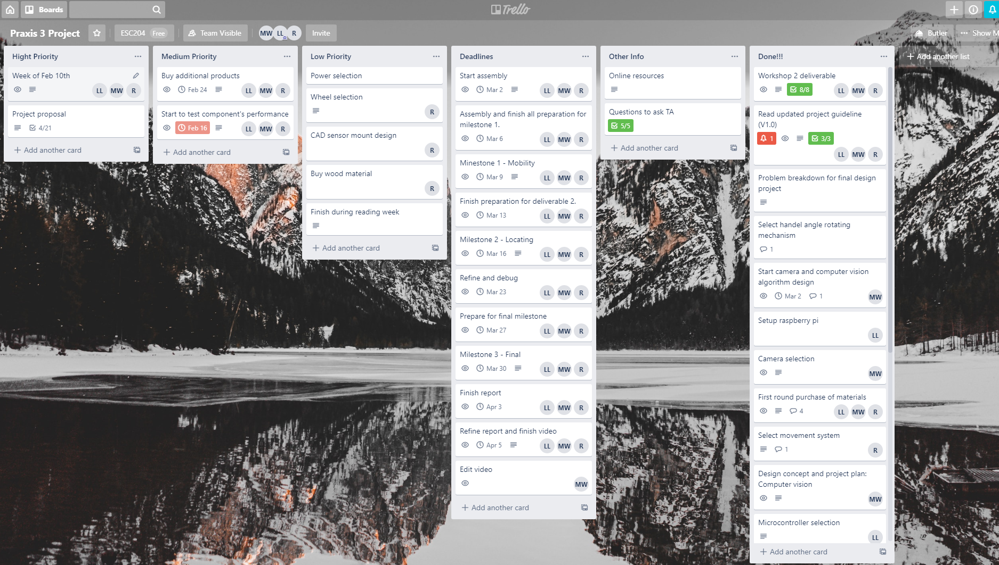

*Figure 13: A screenshot of the most updated trello project board*

## Appendix

**Appendix A**: Detailed objectives, metrics, criteria, and constraints for overall mechatronics system and individual components

*Table 3: Summary of detailed objectives, metrics, criteria, and constraints for overall mechatronics system*

|  |  |  |
| --- | --- | --- |
| Detailed Objectives | Metrics | Constraints and Criteria |
| **Design for capability**  Maximize accuracy and precision of controls, movement, and sensing for the solution  Maximize the capability of the solution in various test scenarios | The average error in measuring or moving what it aims to measure or moves, in distance or angular degrees [23] | **Criteria**: **Lower** is better.  **Constraint:** Must be less than 2 mm or 10 degrees (estimated maximum tolerable error for charging plug to be properly inserted) (see Appendix B) |
| Time taken to accomplish the task [24] | **Criteria: Shorter** time is better.  **Constraints**: Must not exceed two minutes, the time limit [2] |
| Percentage of successful completion of task in random scenarios [24] | **Criteria: Higher percentage** is better |
| **Design for Simplicity**  Maximize the simplicity of operation | Time taken to complete the setup (system is in its starting position with charger plug securely attached) | **Criteria: Shorter** time is better.  **Constraints**: Must not exceed three minutes, the time limit [2] |
| Distance travelled to accomplish the task [24] | **Criteria**: **Shorter** distance is better |
| Number of degrees of freedom (DOF) involved in total and number of DOFs operating at a time [25] | **Criteria**: **Fewer** is better. To simplify the control system, the robotic system should move one DOF at a time. |
| **Design for Ease of Assembly**  Maximize the ease of constructing the robot | Number of components involved in the system and number of equipment required for construction [25] | **Criteria**: **Fewer** is better.  **Constraints**: the system must be constructed using machines at the Light Fabrication Facility (LFF), the only viable workshop for the design team |
| Accessibility of components, measured in time required for shipment | **Criteria: Shorter** time is better.  **Constraints**: Must not exceed two weeks, the time between project milestones [2] |
| **Design for Feasibility**  Be adequately priced so that the design group can afford the cost of construction and average electric car owners can afford the device  Be adequately sized so that it can be used and stored in an average sized garage | Unit price for each component and combined cost for selected components | **Criteria: Lower** cost is better.  **Constraints**: Must not exceed $300 [2]. Should be well under $300 to prepare for unanticipated cost and to reduce the burden on student loans |
| Estimated operating cost (including energy consumption and maintenance) over the course of one year [24] | **Criteria: Lower** cost is better. |
| Dimension, in cm, of the solution when stored and in operation | **Criteria: Smaller** volume/ surface area is better.  **Constraints:** Base area must not exceed 2 by 1.5 m [2]. Height must not exceed 213 cm (average height of garage) [26] |
| **Design for Safety**  Follow the Fail Safe Design principles when designing mechanical and electrical components [25] | Number of features in coherence with Fail Safe Design principles [25] | **Criteria: More** features are better.  **Constraints:** Must have a distinct way to command the start of design, and an emergency stop button/switch to stop all actuators |
| Number of potential hazards identified | **Criteria: Fewer** is better.  **Constraints**: Power supply must be UL, CSA approved. Must not have any possible high voltage contacts exposed. Must not have hazardous radiation emitted. |

*Table 4: Summary of detailed objectives, metrics, criteria, and constraints for specific parts*

|  |  |  |  |
| --- | --- | --- | --- |
|  | Metrics | Criteria | Constraints |
| For structural material | Deflection of beam 1m in length under 2.6 kg of load in the middle | - is preferred | Must not exceed 2mm in deflection under test load |
| Surface Roughness | - is preferred | No limit |
| Weight per cm | - is preferred | No limit |
| Cost per cm | - is preferred | No limit |
| Time required to construct a rectangular frame | - is preferred | No limit |
| For linear motion system | Maximum load allowed | + is preferred | Must exceed 2 kg |
| # of tolerable orientations (horizontal and vertical) | + is preferred | No limit |
| Maximum allowed speed and acceleration | + is preferred | Speed must exceed 1.15 cm/s |
| Maximum allowed travel distance | + is preferred | Must exceed 30 cm for vertical orientation, 1.2 m for horizontal orientation |
| Average error in positioning | - is preferred | Must not exceed 2mm |
| For camera | Resolution of camera | + is preferred | No constraints as long as the test is passed. |
| Pose estimation accuracy | + is preferred | No Limit |
| Compatible with microcontroller | Pass is preferred | Must receive pass |
| Extra useful features such as ability to focus | + is preferred | No limit on extra features |
| For distance sensors | Percent error in distance measurement, in ranges from 3cm to 50 cm on average (without rotation) | - is preferred | No limit |
| Maximum angle before error exceeds 10 percent | + is preferred | No limit |
| For Inertial measurement units | Percent error in magnitude displacement measurement, on average | - is preferred | No limit |
| Power supply | Compatibility with current microcontroller | Pass is preferred | Must receive a pass |
| Danger for device through current errors | - is preferred | No Limit |
| Computer vision algorithm | Time taken to locate charger port | - is preferred | Cannot exceed 2 minutes [2] |

**Appendix B**: Images Taken For Test Setup

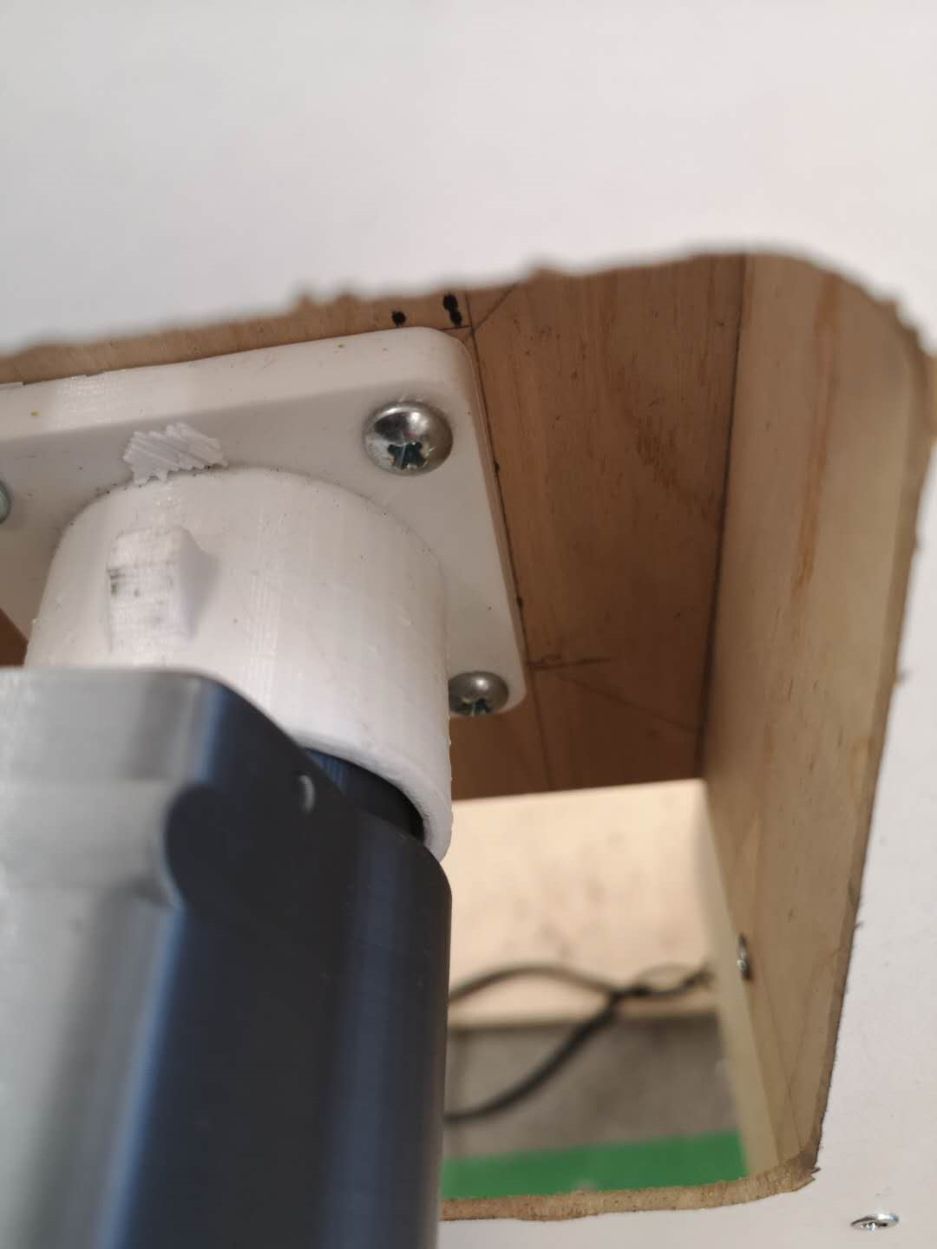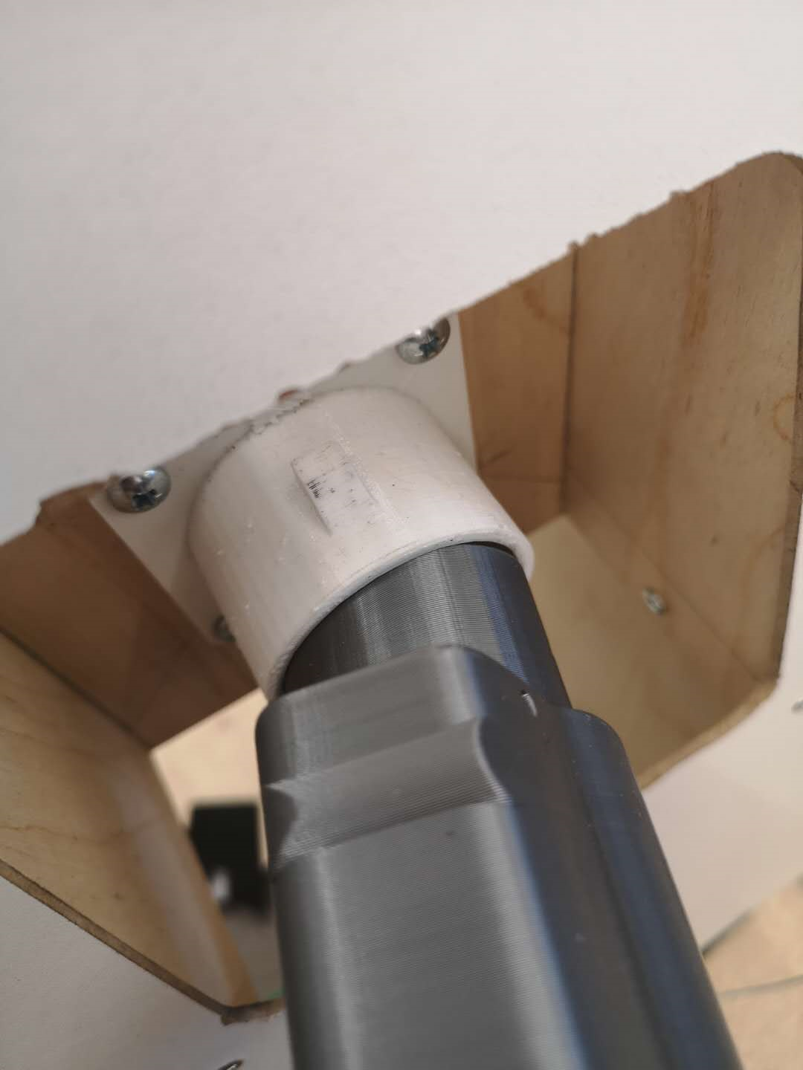

*Figure 14: Images taken showing the tolerable errors of device*

As seen in the figure above, there is a small gap when the plug is fully inserted into the port, which allows the charger plug to be inserted into the port at a slight deviation away from center and at a slight angle. The maximum tolerable error is estimated to be 2mm and 10 degrees.

**Appendix C**: Test Method and Verification Data for Overall Mobility Designs

Because we built low-fidelity prototypes for this testing, objectives such as feasibility and safety were not testable. Thus, all three designs were assumed to perform equally in these categories. For the pugh chart below, the highest score in each category stands for the best performed design.

*Table 5: Pugh chart for evaluating overall mobility designs*

|  |  |  |  |
| --- | --- | --- | --- |
|  | Design 1: Fixed-base cartesian robot | Design 2: Robotic Arm | Design 3: Wheeled Rover |
| Accuracy and Precision of Movement | 2 | 1 | 3 |
| Simplicity in Operation | 2 | 1 | 3 |
| Ease of Assembly | 1 | 3 | 2 |
| Overall Score | 5 | 5 | 8 |

**Appendix D:** Test Method and Verification Data for Structural Materials

1. Translate design requirements

*Table 6: Summary of important design requirements for structural materials*

|  |  |
| --- | --- |
| Function | * A beam to comfortably hold the weight of the electrical system and other structural components. The heaviest components include four stepper motors (285g each), one 30cm lead screw (104g), and two 30mm ball bearing guide rails (700g each). The total weight of these components is 2.6 kg. * To facilitate the linear motion in horizontal direction, if possible. * For ease of assembly, it is ideal to use only one material. |
| Constraints | * Total deflection under desired load should not exceed 2mm, or 10 degrees. * Must be high strength, with a Young’s Modulus greater than 50 MPa * The estimated weight of the entire structure should not exceed 10 kg, otherwise it would be too difficult for the motors to power. * The cost of materials should not exceed $100, the allocation of budget decided by the design team after consideration cost of other components * The shipping time must be under two weeks. * The materials should be easily machinable and/or constructable. |
| Objectives | To maximize structural rigidity, minimize weight, and minimize cost |

To summarize the given the function, objective, and constraint, the material should be a beam with minimum cost and minimum weight, with stiffness prescribed. The corresponding derived material index is $\frac{E^{1/2}}{C_{m}ρ}$, where E is the Young’s modulus, Cm is the cost per mass, and $ρ$ is the density of material. The derivation is shown below [26]:

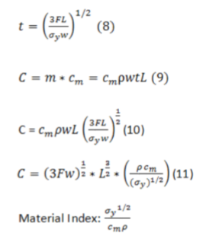

1. Screening of materials:

Given the constraint and the material index, materials are screened. Figure 15 shows the material properties charts and the screening process [27]:

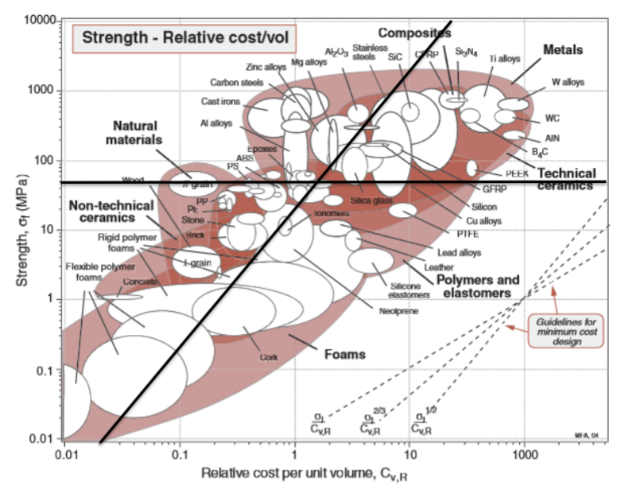

*Figure 15: Cost vs. strength for various construction materials*

The horizontal line represents the minimum strength required for the material, while the slanted line represents the material index. The farther to the left the line is, the stronger the material index.

1. Ranking of materials:

The only materials that fit the constraints are Balsa block plywood, spruce lumber, and aluminum extrusion. Samples of these materials were purchased for testing, which include constructing a rectangular frame, evaluating the ease of construction, and stress testing the frame to test for deflection. A pugh chart containing the verification data and overview of test methods are shown below:

*Table 7: Pugh chart for evaluating structural material*

|  |  |  |  |
| --- | --- | --- | --- |
|  | Balsa block plywood 2’’ x 2’’ | Dried Spruce Lumber 2’’ x 2’’ | Aluminum Extrusion 10 by 10 cm |
| Weight per length (measured with digital scale) | 5.44 g/cm | 3.32 g/cm | 15.1 g/cm |
| Stiffness of material (deflection of beam 1m in length under 2.6 of load in the middle) | No deflection detected | No deflection detected | No deflection detected |
| Surface roughness (qualitative observation) | Fair | Poor, with bumps and holes | Good |
| Ease of Assembly (general comments on constructing a rectangular frame) | Easy to drill through, however, it is difficult to ensure that the frame is leveled. | The presence of moisture caused the blade of the bandsaw machine to burn and become ineffective in cutting. Thus, manual cutting is required, which makes it difficult to cut. | No drilling required. The frame is perfectly leveled due to the perfectly straight construction of aluminium frame. |
| Cost per cm (derived from purchase receipt) | $0.12 (purchase receipt from LFF) | $0.04 (purchase receipt from Home Hardware store) | $0.29 (purchase receipt from Fazstore.ca) |

Given the data above, it can be concluded that through research and physical testing, Balsa plywood is the best choice of material in this design. Despite scoring average, it does not perform poorly in any of the criteria. Spruce lumber, on the other hand, is difficult to be machined due to the presence of moisture, causing the bandsaw to wear out quickly. It also cannot be used as a guide rail system, due to the rough surfaces. Aluminum extrusions on the other hand, even though it is a lot stronger than wood, is a few times heavier and costly. As Balsa wood achieves sufficient stiffness for our use case, it is the most cost-effective choice.

**Appendix E:** Verification Data for Linear Motion System

The converging process is done through research, by finding verification data and comments from online resources. The requirements, “LOSTPED” in short, are developed by Bosch Rexroth’s Linear Motion and Assembly Technologies group to specifically help size and select linear motion systems. Note that these options all satisfy the cost and ease of assembly constraints, and the differences between each are minimal. Requirements for both linear motion for this application are described in detail below:

*Table 8: Summary of requirements for linear motion systems*

|  |  |  |
| --- | --- | --- |
|  | Horizontal Linear Motion | Vertical Linear Motion |
| Source of load | Carries the vertical linear motion system, estimated 5 kg | Carries the servo-powered gripper, charger plug, and camera, estimated 2 kg |
| Orientation | Horizontal, stepper motor preferably located on the side for clean circuit design | Vertical, stepper motor preferably located at the bottom for clean circuit design |
| Speed | Up to 30 seconds is allocated for horizontal motion. This means the system is required to travel at up to approximately 2 cm per second. Acceleration is not important. | Up to 20 seconds is allocated for vertical motion. This means the system is required to travel at up to 1.15 cm per second. Acceleration is not important. |
| Distance of travel | Up to 120 cm | Up to 23 cm |
| Precision | Up to 2mm in tolerable error. Travel accuracy, positioning accuracy, and repeatability are very important here. | |
| Environment factor | Controlled indoor temperature, with minimal dirt, dust, and liquids, thus not an important and concerning factor | |
| Duty cycle | Should be designed for use once a day, the average charging rate for electric cars. [27] However, due to cost constraint, some long-lasting systems, such as a ball-screw system may not be possible. In this case, the system should be designed for at least the duration of this project. | |

The research results for each linear motion system are summarized below [29][30][31].

*Table 9: Pugh chart for converging on possible solutions for linear motion*

|  |  |  |  |
| --- | --- | --- | --- |
|  | Lead Screw  (8mm diameter purchased from LFF) | Rack and Pinion  (3D printed) | Belt Drive  (FULARR Professional GT2 Timing Belt 6mm Width with 20-Teeth 5mm Bore Belt Pulley) |
| Load bearing ability | High load-carrying capacity. | Low load-carrying capacity | Lower load-carrying capacity. Long belt may add to moved mass and inertia, which drive the need for large motor |
| Orientation | Can be used in vertical application. Vertical-axis load will lock in place if power fails. | Can be used in vertical application | Cannot be used in vertical application due to risk of damage |
| Speed requirement | Limited speed due to gear reduction. | Can travel at high speed. However, it cannot withstand high acceleration or deceleration. | Can travel at high speed. However, it cannot withstand high acceleration or deceleration. |
| Capability for long distance | Does not work well in application longer than 1 m. Prone to sagging. | Easy to extend in length by adding additional racks | Can accommodate long travel lengths. However, long distance requires a higher tension force induced on belt, which decreases ability to transmit external force |
| Precision (Travel Accuracy, Positioning Accuracy, and Repeatability) | Relatively high, but low accuracy compared to the costly ball screw and linear motor | Low. Precision rack and pinion is costly. | Low. Due to the plasticity of the belt, it is prone to stretch especially in high tensile loads. However, Kelvar fiber reinforced belts will reduce the extensibility problem |
| Duty Cycle and Durability in Harsh Environment | Not durable as it is easy for debris to access. Lubrication is required. | Not durable as it is easy for debris to access. Lubrication is required. | More durable against elements. |

From the results above, it can be seen that different linear motion systems have their own advantages and disadvantages. For all three linear motion systems, due to the limited budget, the positioning accuracy, durability, and resistance to acceleration are low, but should be sufficient for this application. Rack and pinion are too expensive to purchase off-the-shelf, and thus relies on 3D printing, which is commonly seen to have poor load-carrying capacity and low precision. Lead screw is the ideal solution for movement in z-axis, as it has high load-carrying capacity and can lock in place when power is cut off. Belt-drive, on the other hand, is the best solution for horizontal movement for its ability to function for long distance travel.

**Appendix F:** Calculations and specifications for motors

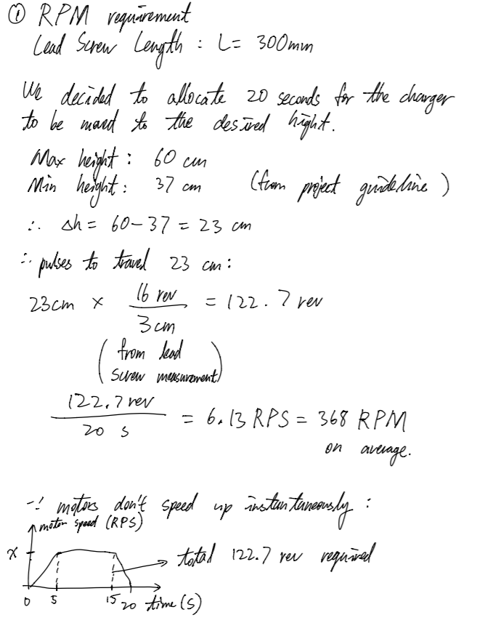

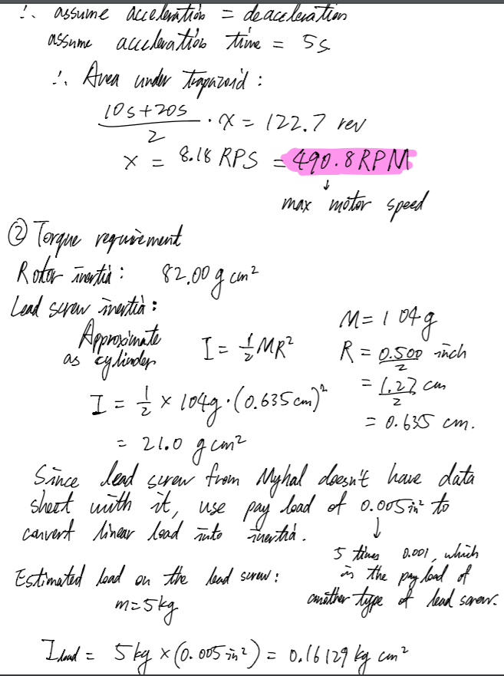

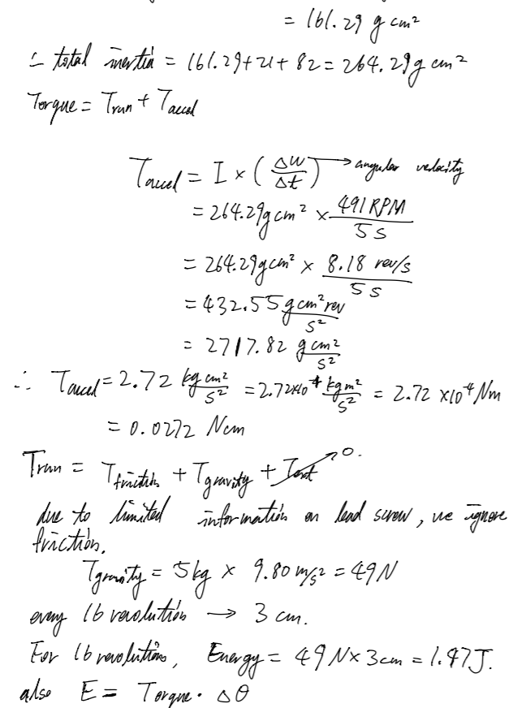

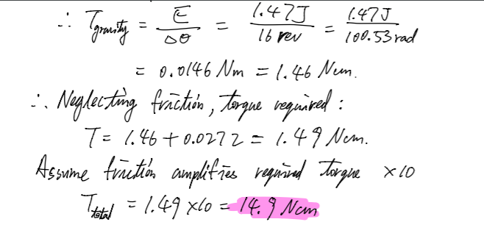

*Figure 16: Rough draft of motor calculations performed by design team*

**Appendix G:** Technical data for microcontrollers

*Table 10: Pugh chart for converging on possible solutions for microcontrollers*

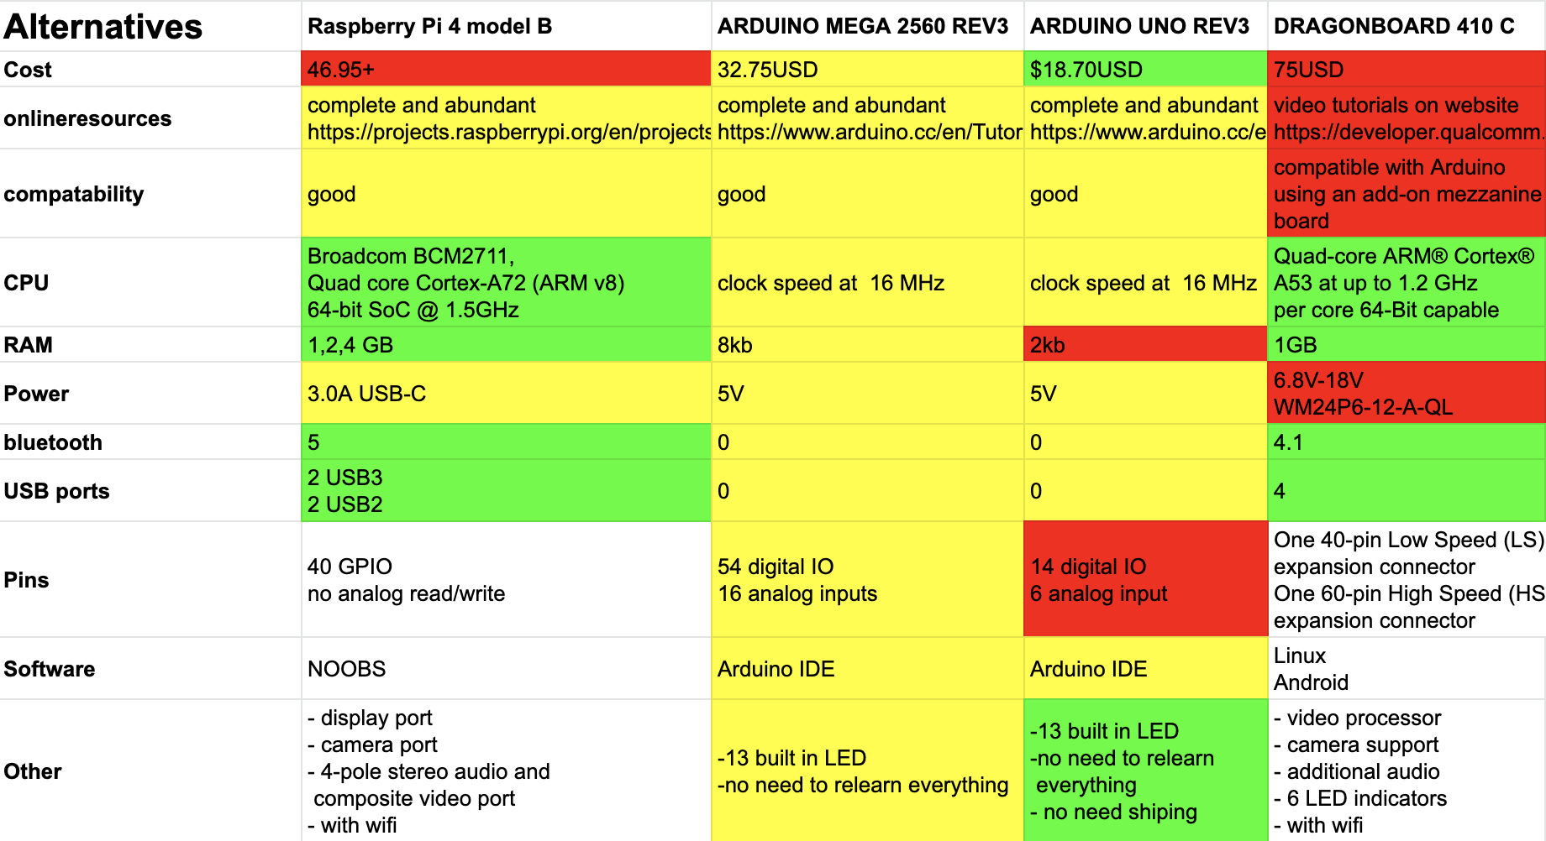

After collecting the technical metrics from online sources, we can see that Raspberry Pi 4 performs the best overall [32][33][34][35]. It is a slightly high-cost computer, but has good compatibility with motors, sensors, and cameras. It also has options for connectivity, with built-in Wifi and Bluetooth. Arduino Uno is a minimalist microcontroller, which is only good for controlling relatively simple tasks. It requires external Bluetooth modules for connectivity. Also, because it does not have sufficient I/O pins, our application would require multiple Arduino Uno to communicate with each other via serial communication. Arduino Mega has sufficient I/O pins to connect with all devices, but otherwise shares similar disadvantages of the Arduino Uno. Dragonboard is a strong but costly computer, and is not easily compatible with motors and other electronic devices. Its performance is more suited for larger projects where many computations and connections are required, but not for this application.

**Appendix H**: Power supply method converging

There are mainly three ways to power the Raspberry Pi. Using the micro USB input, through the GPIO pin, or the USB ports [22]. The standard power supply is through the micro USB input, which is regulated to prevent high currents exceeding limits. Many powers supplies through the micro USB input are available on Amazon and as long as the voltage is at 5V and current is in the range 2 to 3 A. However using the GPIO pins would be a more dangerous choice as there is no current regulation, which may damage the board during usage. The other method charging through a USB port is not common, and cannot be charged through the standard method of simply plugging in a power source. It also has a limit of 500mA, which is not enough for our project.

**Appendix I:** Distance sensors testing

Distance detection requires a distance sensor, or using two cameras for depth detection. Using two cameras will be too complicated for computer vision programming, and hence using simple sensors would be a good idea for student teams to finish on time. The main issue with distance sensors is accuracy of distance measurement, and the following test is used to verify each sensor.

There are no more scientific testing methods than placing a large flat board is placed in front of the sensor at various known distances, and the readings, converted to metric unit, are recorded to find out its accuracy. Another aspect is the angle of deflection. We also test for the maximum angle for measurements to remain relatively accurate.

Not all sensors arrived at the time of writing this proposal. We used two models that were available to us at the time. The maximum angle for both sensors is consistent with the data sheet, which is 15 degrees. During testing, we also found some malfunctioning sensors in the same package of the Elegoo brand. In general both are at a satisfactory level for our project. When new sensors arrive, they will be tested again.

*Table 11: Summary of test results for distance sensors*

|  |  |  |  |  |  |  |  |  |  |  |
| --- | --- | --- | --- | --- | --- | --- | --- | --- | --- | --- |
| Actual Distance (cm) | 5 | 10 | 15 | 20 | 25 | 30 | 35 | 40 | 45 | 50 |
| Elegoo HC-SR04 (cm) | 4 | 10 | 14 | 19 | 25 | 29 | 34 | 39 | 44 | 48 |
| Myhal HC-SR04 (cm) | 4 | 10 | 14 | 20 | 24 | 29 | 36 | 39 | 45 | 49 |

*Table 12: Pugh chart for converging on possible solutions of distance sensors*

|  |  |  |  |
| --- | --- | --- | --- |
| Sensor | Accessibility | Percent Error | Cost ($) |
| Elegoo HCSR-04 | Pass | 5 | 2.40 |
| Myhal HCSR-04 | Pass | 4 | 1.13 |
| HCSR-05 | Fail | N/A | 4.83 |

**Appendix J**: Inertial measurement units testing

The inertial measurement unit combines both the accelerometer and the gyroscope, and measures both linear motion and angular motion. The test involves two categories, one where the IMU is moved abruptly to test its ability in its linear and angular measurements, and the other where the IMU is moved gradually. This method is recommended by P. Jakanek from Slovak University of Technology with some modification [36].

However, we did not receive the IMU with enough time to perform any physical testing, and once they arrive, they will be tested with our methods. Meanwhile, our convergence result is purely based off of data sheets.

**Appendix K: Camera testing**

The purpose of camera testing is to find the right camera for feature detection, working with the OpenCV library. Compatibility with computer vision is an important factor. The test involves a simple program made by OpenCV, together with a chessboard pattern. It tests how well the camera can measure the angle of different planes. The test begins with calibration of cameras, which is a process of generating the camera matrix. Then it is aimed at a chessboard for angle detection, with OpenCV functions such as cv2.findChessBoardCorners() and cv2.solvePnPRansac(). Euler angles can then be calculated to find the rotation of the chessboard plane. Raw data gathered for camera angle detection using pose estimation from methods above. ArduCam did not calibrate properly with the chessboard pattern, which is then excluded from our discussion below. Both cameras had okay performances, and the data are quite close to each other. However, the Microsoft webcam is more accurate by a small margin when under 20 degrees. Furthermore, the webcam is able to focus at various distances, which counts as an additional feature, therefore maximizing chances for accuracy.

*Table 13: Summary of test results for cameras*

|  |  |  |  |  |
| --- | --- | --- | --- | --- |
| Actual Angle (degrees) | 0 | 10 | 20 | 30 |
| Microsoft HD LifeCam-500 (degrees) | 1 | 12 | 19 | 24 |
| Raspberry Pi Module (degrees) | 2 | 8 | 22 | 26 |

*Table 14: Pugh chart for converging on possible solutions of cameras*

|  |  |  |  |
| --- | --- | --- | --- |
| Camera | Resolution | Compatible with OpenCV | Cost ($) |
| Microsoft HD LifeCam-5000 | 720p | Pass | 17.99 |
| Raspberry Pi Camera Module | 1080p | Pass | 19.99 |
| ArduCam  Camera Module | 1080p | Fail | 17.78 |

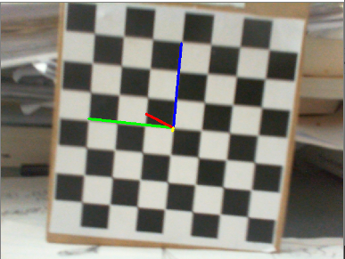

*Figure 17. Chessboard angle detection for testing*

**Appendix L**: Algorithm converging

*Table 14: Pugh chart for converging on possible sensing/locating systems*

|  |  |  |
| --- | --- | --- |
| Algorithm | Ease of implementation | Time to process (s) |
| Using two cameras | - | - |
| Using one camera and ultrasonic sensors | + | + |
| Using chessboard marker | + | + |
| Without chessboard marker | - | - |

The most important algorithm is detection of port location, which makes use of gathered data from all sensors. As previously mentioned, using two cameras would require too much work in dealing with black-box functions from OpenCV. Using no cameras at all would also be impossible since distance sensors are not accurate, especially in dealing with planes at an angle. Using one camera would take care of this problem, with pose estimation to obtain an angle, and after some rotation, the ultrasonic sensors can take care of distance measurement for control of translation of the system, and also serves as extra safety if we need to confirm calculation results from computer vision. Because of the limitation that we have not assembled everything together, we only tested the computer vision algorithm, which is the most foreign topic for us, in conjunction with camera testing.

Another choice to make whether a marker will be used for computer vision feature detection, such as using a chessboard. Our test results show that it is almost impossible to achieve port recognition without any marker, such as the picture below. Even though the circle is drawn relatively correctly, it is off by a small factor, but big enough when the system is far away, or at an angle. It relies on Hough circle transform from the OpenCV library, which detects circles in a picture. However, it is not possible to detect circles at an angle, which makes the objective of angle detection impossible. Another problem with using circle transforms is the amount of time taken for the computer to process. It takes roughly 20 to 30 seconds to process each image. It would then be difficult to fit the whole process within the time constraint of 2 minutes. However, using markers for detection avoids this problem. A chessboard marker is simple to detect with the OpenCV function cv2.findChessboardCorners(). Pose estimation can be done by the OpenCV function cv2.solvePnPRansac(). Euler angles can then be calculated from rotation vectors obtained from solvePnPRansac function, which supplies information for rotation. This process takes less than a second. The marker’s relative position on the image will also indicate the translation motion of the system.

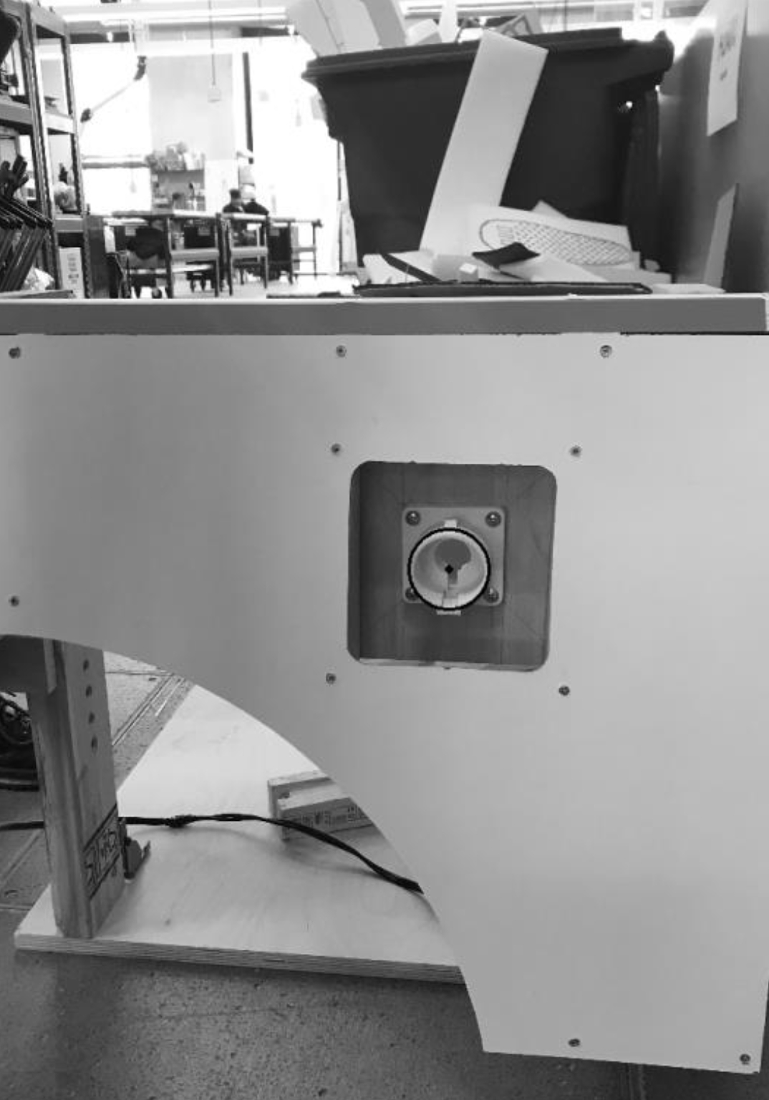

*Figure 18. OpenCV detection of a circular shaped object. Note that it is not very accurate.*

## References

[1] P. Hertzke and N. Müller, “Expanding electric-vehicle adoption despite early growing pains,” *McKinsey & Company*. [Online]. Available: https://www.mckinsey.com/industries/automotive-and-assembly/our-insights/expanding-electric-vehicle-adoption-despite-early-growing-pains. [Accessed: 23-Feb-2020].

[2] C. Liu, *ESC204 Project Guideline*, 2020

[3] “Raspberry Pi,” *Wikipedia*, 23-Feb-2020. [Online]. Available: https://en.wikipedia.org/wiki/Raspberry_Pi#/. [Accessed: 24-Feb-2020].

[4] *How much current flowing to VMOT pin if stepper motor driver set to 1 A?* [Online]. Available: https://forum.arduino.cc/index.php?topic=613747.0. [Accessed: 24-Feb-2020].

[5] “Logitech C310 Webcam 720p 30fps HD USB2.0 Wired Web Camera Live Conference Video,” *eBay*. [Online]. Available: https://www.ebay.ca/itm/Logitech-C310-Webcam-720p-30fps-HD-USB2-0-Wired-Web-Camera-Live-Conference-Video-/293212178592. [Accessed: 24-Feb-2020].

[6] C. Liu, *ESC204 Workshop 4 Motors and Drivers*, 2020

[7] *How to Use a Breadboard*. [Online]. Available: https://learn.sparkfun.com/tutorials/how-to-use-a-breadboard/all. [Accessed: 24-Feb-2020].

[8] G. B. Reshko, M. T. Mason, and I. R. Nourbakhsh, “Rapid Prototyping of Small Robots,” Jul. 2000.

[9] *StackPath*. [Online]. Available: https://www.machinedesign.com/archive/article/21818367/consider-the-whole-system-when-choosing-linearmotion-components. [Accessed: 24-Feb-2020].

[10] “Sizing and Selecting Linear Motion Systems: How ‘LOSTPED’ Can Help,” *controldesign*. [Online]. Available: https://www.controldesign.com/assets/10WPpdf/101213_BRL_Lostped.pdf. [Accessed: 23-Feb-2020].

[11] Editor, “Pros and cons of linear screw drive actuators,” *Linear Motion Tips*, 26-Mar-2017. [Online]. Available: https://www.linearmotiontips.com/as-the-screw-turns/. [Accessed: 24-Feb-2020].

[12] “SureStep Stepper Motors - How to Choose and Use (Part I),” 04-Aug-2016. [Online]. Available: https://www.youtube.com/watch?v=-ZYQ-GqraLc. [Accessed: 23-Feb-2020].

[13] “SureStep™ Stepping Systems User Manual,” *automationdirect*, 2004. [Online]. Available: https://cdn.automationdirect.com/static/manuals/surestepmanual/surestepmanual.pdf. [Accessed: 23-Feb-2020].

[14] “17HS19-2004S1 Full Datasheet,” *omc-stepperonline*. [Online]. Available: https://www.omc-stepperonline.com/download/17HS19-2004S1.pdf. [Accessed: 23-Feb-2020].

[15] “17HS19-2004S1 Torque Curve,” *omc-stepperonline*. [Online]. Available: https://www.omc-stepperonline.com/download/17HS19-2004S1_Torque_Curve.pdf. [Accessed: 23-Feb-2020].

[16] “378-ln11,” 15-Nov-2001. [Online]. Available: https://courses.cs.washington.edu/courses/cse378/01au/files/pdf/378-ln11.pdf. [Accessed: 23-Feb-2020].

[17] J. Koon, “Key factors to consider when choosing a microcontroller,” *Microcontroller Tips*. [Online]. Available: https://www.microcontrollertips.com/key-factors-consider-choosing-microcontroller/. [Accessed: 24-Feb-2020].

[18]“Arduino ultrasonic sensor (HC-SR04 or HY-SRF05),” *Energiazero*. [Online]. Available: http://www.energiazero.org/arduino_sensori/Arduino ultrasonic sensor (HC-SR04 or HY-SRF05).pdf. [Accessed: 23-Feb-2020].

[19]G. Ahearn, *Machine Vision Cameras: Making the Right Selection*, Vision Spectra.

[20]“MPU-6000 and MPU-6050 Product Specification Revision 3.” [Online]. Available: https://www.invensense.com/wp-content/uploads/2015/02/MPU-6000-Datasheet1.pdf. [Accessed: 23-Feb-2020].

[21]“MPU-9250 Product Specification Revision 1 - InvenSense.” [Online]. Available: http://www.invensense.com/wp-content/uploads/2015/02/PS-MPU-9250A-01-v1.1.pdf. [Accessed: 23-Feb-2020].

[22]P. Hut, “How do I power my Raspberry Pi?,” *The Pi Hut*, 25-Jun-2014. [Online]. Available: https://thepihut.com/blogs/raspberry-pi-tutorials/how-do-i-power-my-raspberry-pi. [Accessed: 24-Feb-2020].

[23] J. Falco, K. V. Wyk, and E. Messina, “Performance Metrics and Test Methods for Robotic Hands,” 2018.

[24] N. D. M. Ceballos, J. Alejandro, and N. Londono, “Quantitative Performance Metrics for Mobile Robots Navigation,” *Mobile Robots Navigation*, Jan. 2010.

[25] “Philosophy of Robot Design (Ⅳ) - Simplicity at Its Best,” *NXROBO BLOG*, 11-Oct-2017. [Online]. Available: https://blog.nxrobo.com/philosophy-robot-design-Ⅳ-simplicity-best/. [Accessed: 23-Feb-2020].

[26] R. Worst, “Standard Garage Size: Diagrams & Dimensions Up to 4 Car Garages: WR,” *Worst Room*, 27-Nov-2019. [Online]. Available: https://worstroom.com/standard-garage-size/. [Accessed: 23-Feb-2020].

[27] A. Pavlak, “Material Selection Analysis for the Development of an Integrated Surface Vehicle System,” May 2016.

[28] “Charging your EV: how do EV charging stations work?,” EnergySage. [Online]. Available: https://www.energysage.com/electric-vehicles/charging-your-ev/. [Accessed: 24-Feb-2020].

[29] *StackPath*. [Online]. Available: https://www.machinedesign.com/mechanical-motion-systems/linear-motion/article/21831764/go-long-the-pros-and-cons-of-rackandpinion-systems. [Accessed: 24-Feb-2020].

[30] D. Collins, “Linear actuators: belt driven vs. rack and pinion driven,” *Linear Motion Tips*, 24-Jan-2017. [Online]. Available: https://www.linearmotiontips.com/linear-actuators-belt-driven-vs-rack-and-pinion-driven/. [Accessed: 24-Feb-2020].

[31] “Picking the Right Linear Positioning Device,” *Design Engineering*. [Online]. Available: https://www.design-engineering.com/features/linear-positioning-device/. [Accessed: 24-Feb-2020].

[32] “Raspberry Pi 4 Model B specifications – Raspberry Pi,” *Raspberry Pi 4 Model B specifications – Raspberry Pi*. [Online]. Available: https://www.raspberrypi.org/products/raspberry-pi-4-model-b/specifications/. [Accessed: 24-Feb-2020].

[33] “DRAGONBOARD 410 C by Arrow Development Tools: Embedded System Development Boards and Kits,” *Arrow.com*. [Online]. Available: https://www.arrow.com/en/products/dragonboard410c/arrow-development-tools. [Accessed: 24-Feb-2020].

[34] “Arduino Mega 2560 Rev3,” *Arduino Mega 2560 Rev3 | Arduino Official Store*. [Online]. Available: https://store.arduino.cc/usa/mega-2560-r3. [Accessed: 24-Feb-2020].

[35] “Arduino Uno Rev3,” *Arduino Uno Rev3 | Arduino Official Store*. [Online]. Available: https://store.arduino.cc/usa/arduino-uno-rev3. [Accessed: 24-Feb-2020].

[36] P. Kajánek, “Testing of the Possibilities of Using IMUs with Different Types of Movements,” *Geoinformatics FCE CTU*, vol. 12, pp. 61–66, Mar. 2014.